Cloud Security – Assignment 3

Set Up a Web Application on Amazon EC2

Name: Sanika Kadam
2124UCSF1112

Objective

To launch a virtual server on Amazon EC2, secure it with a Security Group that allows SSH (port 22) only from my IP and HTTP (port 80) for public access, connect to it over SSH, install the Nginx web server, deploy a simple HTML web application, and verify it in a web browser.

- Architecture

User Browser → Internet → Security Group (ports 22, 80) → EC2 Instance (Ubuntu) → Nginx → index.html

Component Role
EC2 instance Virtual server hosting the application Key pair (.pem) Private key for secure SSH authentication
Security Group Virtual firewall controlling inbound and outbound traffic Nginx Web server listening on port 80
index.html The deployed web application

Step 1: Launch an EC2 Instance

  - In to the AWS Management Console, opened EC2, and clicked Launch instance.
  - Name: my-web-server
  - AMI: Ubuntu Server 24.04 LTS (Free tier eligible)
  - Instance type: t2.micro / t3.micro
  - Key pair: created my-ec2-key (RSA, .pem format) and stored it safely.
  - Storage: default 8 GB gp3.
  - Clicked Launch instance.

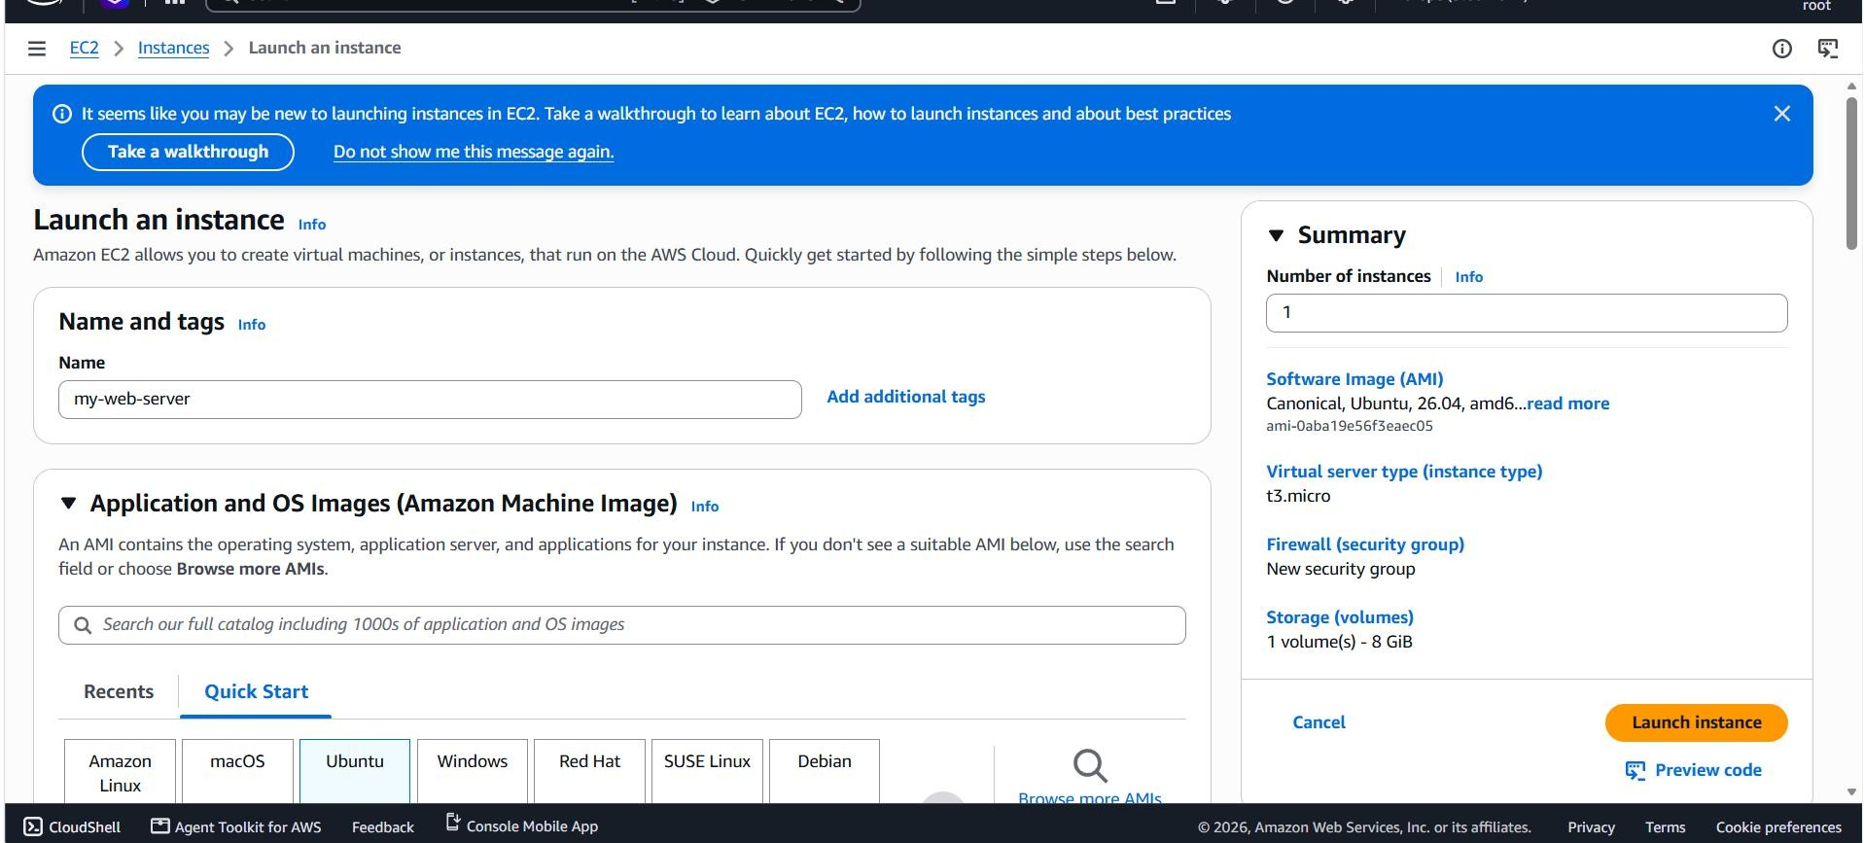

Step 2: Configure the Security Group

A security group named web-server-sg was configured with these inbound rules:

Type Protocol Port Source Purpose SSH TCP 22 My IP Admin access only from my machine HTTP TCP 80 0.0.0.0/0 Public web access
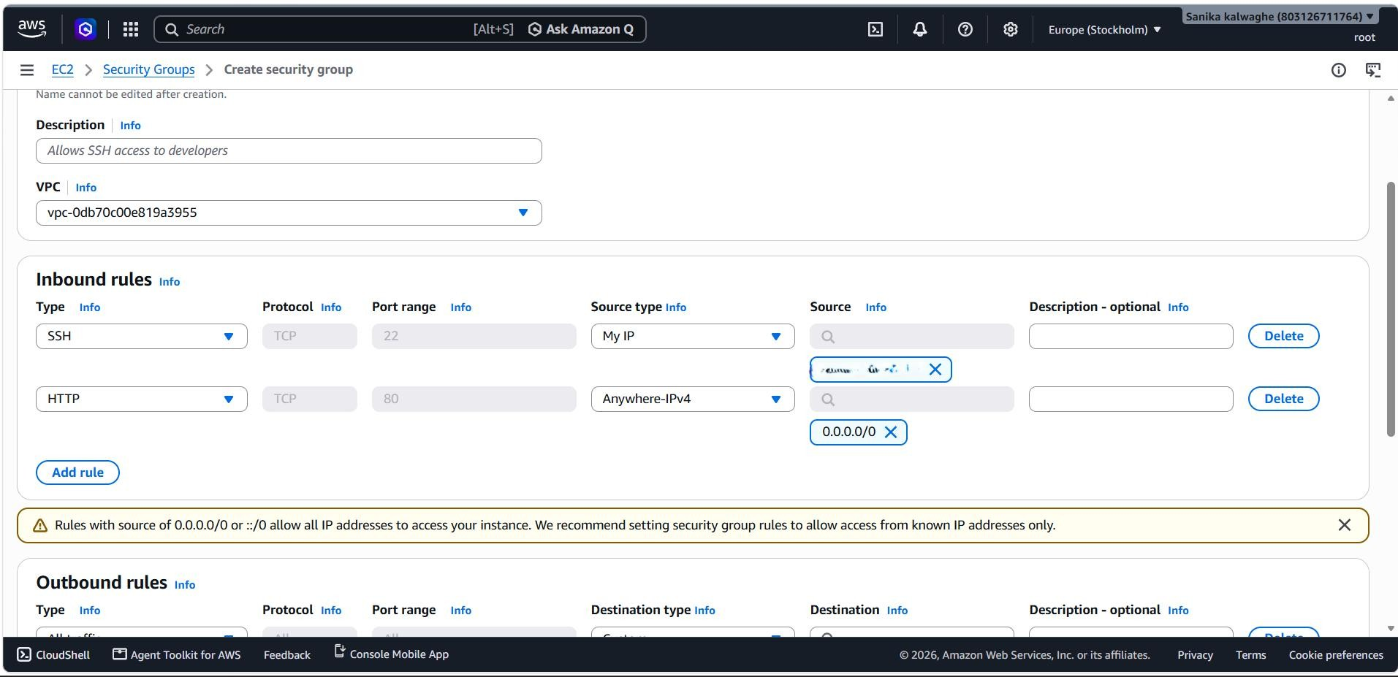

Step 3: Connect to the Instance via SSH

Command run from Windows PowerShell:
ssh -i "C:\Users\Asus\Downloads\my-ec2-key.pem" ubuntu@ip

Step 4: Install and Configure Nginx

sudo apt update && sudo apt upgrade -y sudo apt install nginx -y
sudo systemctl start nginx sudo systemctl enable nginx sudo systemctl status nginx

Step 5: Deploy a Simple HTML Web Application

cd /var/www/html
sudo mv index.nginx-debian.html index.nginx-debian.html.bak sudo nano index.html

Contents of index.html
<!DOCTYPE html>
<html lang="en">
<head>
<meta charset="UTF-8">
<meta name="viewport" content="width=device-width, initial-scale=1.0">
<title>My EC2 Web App</title>
<style>
body { font-family: Arial, sans-serif; background: #f0f4f8; text-align: center; padding-top: 80px; }
h1 { color: #232f3e; } p { color: #555; }
.badge { display: inline-block; background: #ff9900; color: #fff; padding: 8px 16px; border-radius: 6px; }
</style>
</head>
<body>
<h1>Hello from Amazon EC2!</h1>
<p>This web application is hosted on an Ubuntu EC2 instance using Nginx.</p>
<span class="badge">Deployed by: YOUR NAME</span>
</body>
</html>

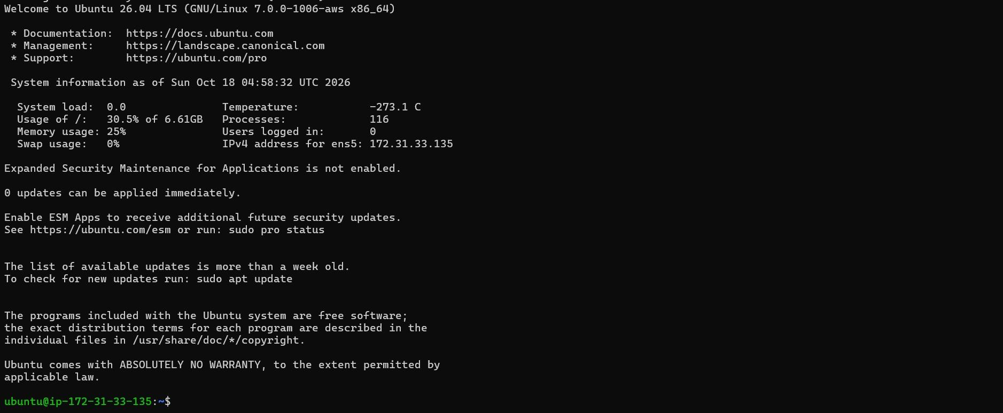
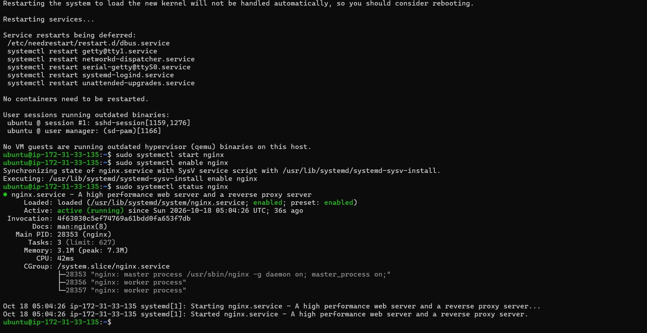
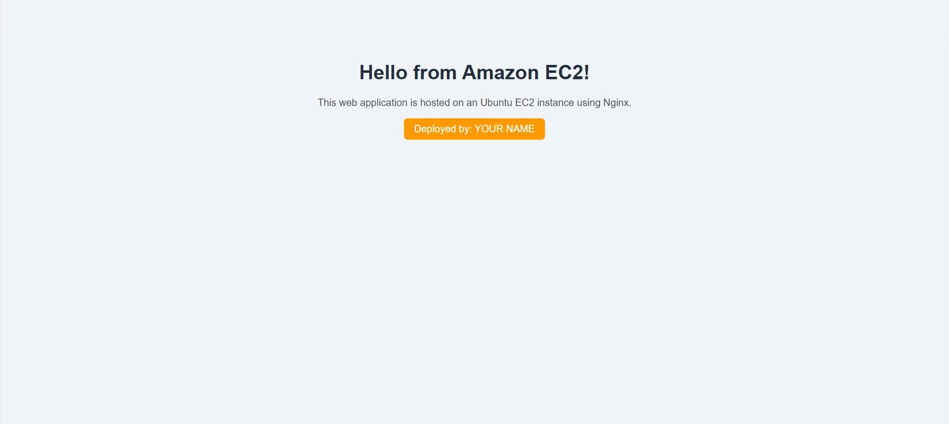

Conclusion

An EC2 instance was launched, secured with a least-privilege Security Group, accessed over key-based SSH, configured with the Nginx web server, and used to host a simple HTML application reachable from a browser. The exercise covered virtual

servers, network security, remote administration and web deployment, along with practical troubleshooting of connectivity problems.

